Ice Machines

# Background

Should Preventive Medicine (PM) personnel collect ice samples from ice machines to test for coliform bacteria? Which ice machines should be sampled and tested? How many ice machines should be sampled and tested each week? Where are the requirements for sampling and testing of ice found?

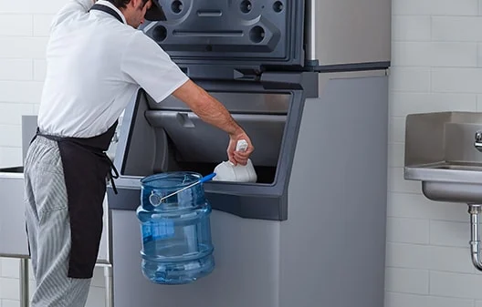

Ice bin in a food service facility

Ice machines can be found in a variety of settings on Navy installations and vessels. They are most commonly found in food service settings. They are also found in healthcare facilities, office spaces, recreational venues, and living spaces.

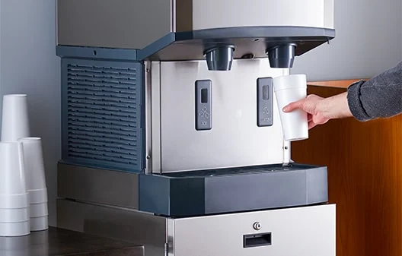

Combination ice and water dispenser

Like the water it is made from, ice must be produced, stored and handled with care to prevent the introduction of contaminants that could harm individuals who ingest it or who are otherwise exposed to the ice.

# What are the requirements?

Health and sanitation requirements for water and ice that is fit for human consumption are covered in several documents, based upon the location where the ice is being produced, and the use of the ice.

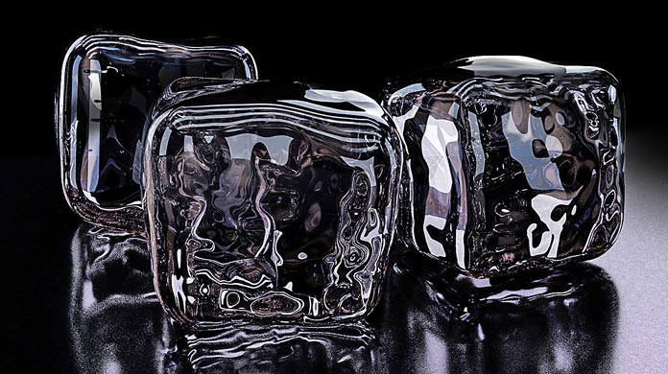

NAVMED P 5010-1, *Tri-Service Food Code,* covers ice machines in food service facilities and ice to be used for human consumption. NAVMED P 5010-5, *Water Quality for Shore Installations,* pertains to public health surveillance of drinking water on Navy installations. NAVMED P 5010-6, *Water Quality Afloat* provides guidance for public health surveillance of drinking water on Navy ships and submarines. At Navy healthcare facilities, there are Joint Commission on Accreditation of Healthcare Organizations (JCAHO) requirements that are applicable to ice and ice machines above and beyond those covered in NAVMED P 5010-1 and P 5010-5.

Outdated versions of NAVMED P 5010-1, P 5010-5, and P 5010-6 have directed Preventive Medicine personnel to include sampling and testing of ice machines as part of their public health surveillance programs for drinking water or food sanitation and safety. As a result, many PM Department sampling plans still include sampling and coliform testing of ice from a representative number of ice machines at their installation or in a facility.

# Discussion

Ice machines are subject to contamination from improper control of condensation drain lines (for example, discharging directly into a sewage drain without maintaining an air gap), contaminated ice scoops, unhygienic handling of ice, and from other environmental sources. Over time, the interior of ice bins become unsanitary due to development of mold/mildew and mineral buildup, which can harbor bacteria. In-line water filters that remove sediment, rust, and chlorine taste and odor from the water may become a prime environment for bacterial growth if they are not maintained and replaced at the proper intervals.

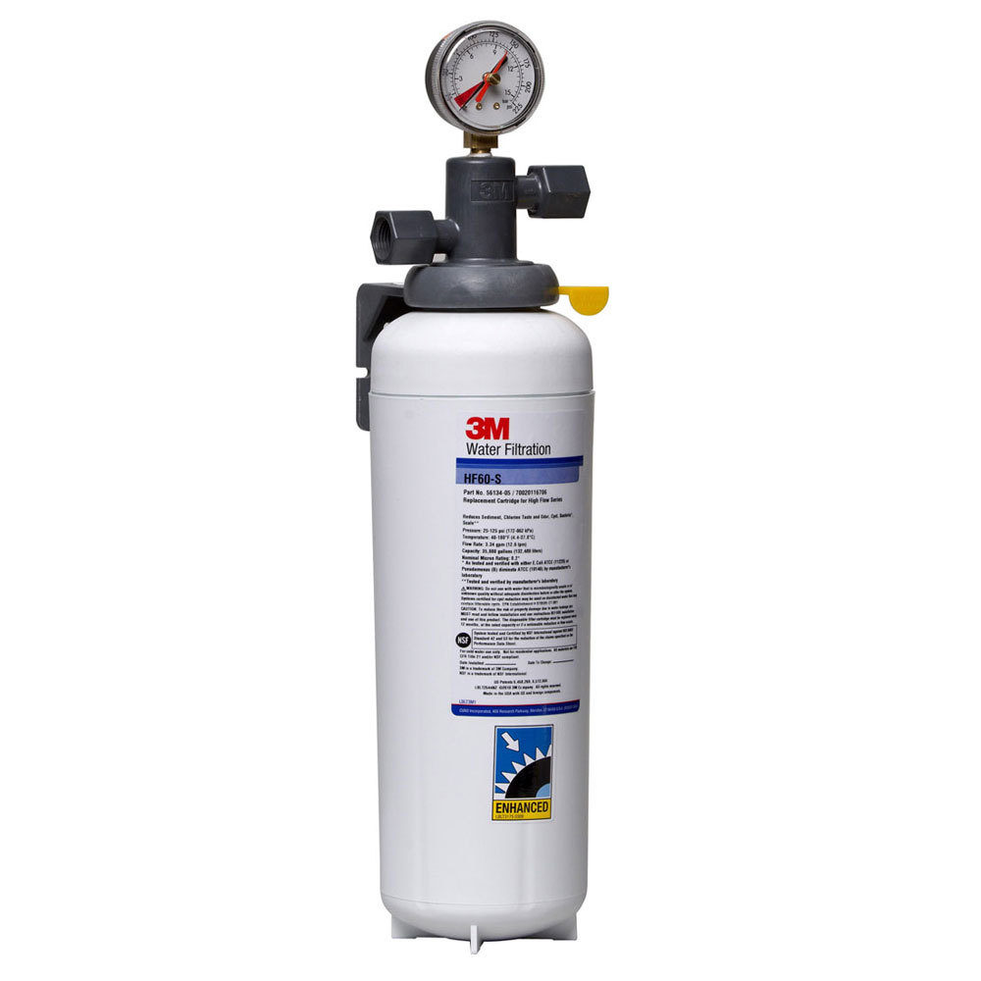

Ice maker in-line water filter

Given potential sources of contamination and types of bacteria involved, coliform testing of ice is not the test of choice. Heterotrophic plate count (HPC) is more suitable for testing of ice samples. However, HPC testing is not a capability that Navy PM assets are equipped with or trained to perform.

# Guidance for Preventive Medicine Personnel

NAVMED P 5010-5, *Water Quality for Shore Installations,* contains no requirement for sampling and testing of ice from food service facility ice machines. Instead, it emphasizes water supply coming from an approved source, prevention and elimination of cross-connections, and maintenance of in-line water filters. It also directs water sampling and testing drinking water for disinfectant residual and coliform bacteria from cold-water faucets in key locations. Appendix F contains a guide for collecting and testing ice samples for circumstances where testing of ice is indicated. Article 3-202.16 of the *Tri-Service Food Code* recommends risk-based sampling and bacteriological testing of ice produced in a food establishment used as a cooling medium in food and drinks. However, it does not assign any quantity of samples or frequency for testing of ice. The Tri-Service Food Code along with P 5010-6 and multiple JCAHO standards heavily emphasize proper cleaning, disinfection, and maintenance of ice machines and proper maintenance and replacement of in-line water filters per manufacturer recommendation in order to prevent potential contamination of ice.

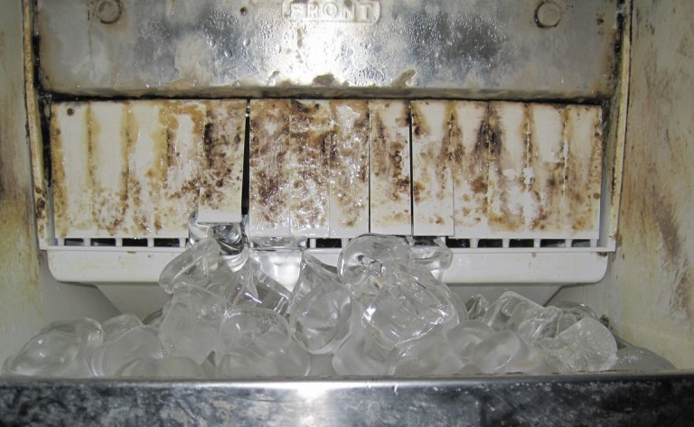

Ice maker in need of cleaning and disinfecting.

During sanitation inspections, PM personnel should visually inspect ice machines to ensure that there are no unsanitary conditions present that could result in contamination of ice. They should also verify that cleaning, disinfection, and maintenance of ice machines and replacement of in-line water filters is being completed and documented per manufacturer recommendation by reviewing maintenance and cleaning logs for the facility’s ice machines.

Routine collecting and testing of ice samples for coliform bacteria is not necessary or required unless potential coliform contamination of ice is suspected. Risk-based scenarios may indicate routine testing of ice in settings such as a major installation dining facility or a hospital galley.

Since the in-line carbon filters remove chlorine from the water, testing ice samples for free-available chlorine (FAC) is not necessary or required.

**For more information on Ice Machines:**

**Learn more:** [NMCPHC Food Sanitation and Safety](https://www.med.navy.mil/Navy-Marine-Corps-Public-Health-Center/Preventive-Medicine/Program-and-Policy-Support/Food-Sanitation-and-Safety/)

**Learn more:** [NMCPHC Water Sanitation and Safety](https://www.med.navy.mil/Navy-Marine-Corps-Public-Health-Center/Preventive-Medicine/Program-and-Policy-Support/Water-Sanitation-and-Safety/)

**Learn more:** [JCAHO Environment of Care-Ice and Ice Machines](https://www.jointcommission.org/standards/standard-faqs/ambulatory/environment-of-care-ec/000001242/)

**Learn more:** [Recommendations of CDC and the Healthcare Infection Control Practices Advisory Committee (HICPAC)](https://www.cdc.gov/mmwr/preview/mmwrhtml/rr5210a1.htm)